Mrs. Biggs 2nd Grade School Supply List  - 1 pair of over the ear headphones  - 1 pair of blunt tip scissors  - 2 plain, spiral notebooks (no names please)  - 2 plain, plastic prong folders (no names please)  - 1 24+ package of plain, yellow pencils  - 5 boxes of crayons (Crayola lasts the longest)  - 1 crayon box  - 16-20 glue sticks (Elmer’s lasts the longest)  - 1 roll of paper towels  - 2 packs of white copy paper  - 1 box of Clorox wipes  - 1 hand sanitizer  Additional donations of any supply list items would be greatly appreciated  Amazon Classroom Wishlist:  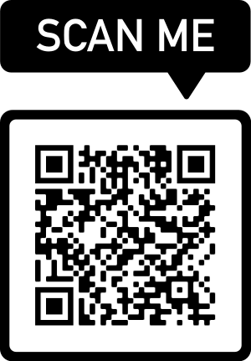 | Mrs. Biggs 2nd Grade School Supply List  - 1 pair of over the ear headphones  - 1 pair of blunt tip scissors  - 2 plain, spiral notebooks (no names please)  - 2 plain, plastic prong folders (no names please)  - 1 24+ package of plain, yellow pencils  - 5 boxes of crayons (Crayola lasts the longest)  - 1 crayon box  - 16-20 glue sticks (Elmer’s lasts the longest)  - 1 roll of paper towels  - 2 packs of white copy paper  - 1 box of Clorox wipes  - 1 hand sanitizer  Additional donations of any supply list items would be greatly appreciated  Amazon Classroom Wishlist:

